QUES1:
Which one is fast between list and dictionary in creation, insertion, searching, deletion?

ANS:

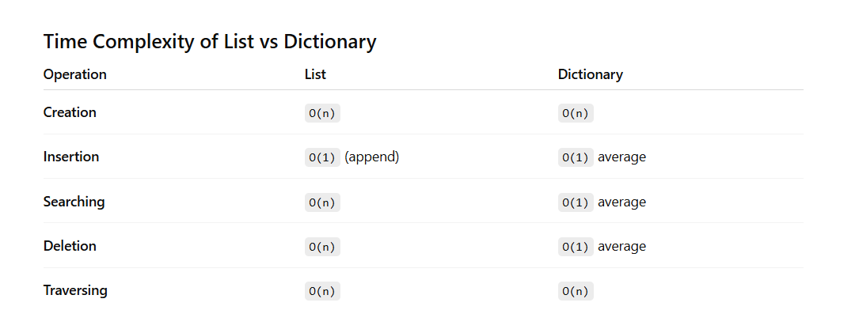

INSERTION:

Data Structure | Time Complexity
List (append) | O(1)average
List (insert at beginning/middle) | O(n)
Dictionary | O(n)average

List Insertion
1. Append at End
number = [1, 2, 3]
number.append(4)
Python adds element at the end.
|1|2|3|4|
So average complexity:
O(1)

2. Insert in Middle/Beginning
number.insert(0, 100)
All elements shift right:
Before: |1|2|3|
After: |100|1|2|3|
Shifting takes time:
O(n)

Dictionary Insertion
data["a"] = 10
Python:
- Calculates hash
- Directly stores value
No shifting needed.
Average complexity:
O(1)

CREATION:
In creation, usually List is faster than Dictionary.

Why?
List Creation
number = [1, 2, 3]
Python only stores values sequentially in memory.
|1|2|3|
Very simple process.

Dictionary Creation
data = {"a":1, "b":2}
Python must:
- Create a hash table
- Calculate hash for each key
- Store key-value pairs
Extra internal work is required.

SEARCHING:
List
A list works like:
[10, 20, 30, 40]
Stored in memory continuously:
|10|20|30|40|
To search 30, Python may check:
- 10 ❌
- 20 ❌
- 30 ✅
So searching takes more time.

Dictionary
A dictionary works using a hash table.
data = {"a":10, "b":20}
Python converts the key into a hash value:
hash("a") → memory location
So it directly jumps to the value instead of checking one by one.
NOTE:
If the required element is at the first position in both a list and a dictionary, then usually the list can be slightly faster for that one specific case.
Reason:
- List:
  - Python checks first element directly.
  - No hashing calculation needed.
- Dictionary:
  - Python first calculates the hash of the key.
  - Then finds the memory location.
DELETION:
List Deletion
Example:
number = [10, 20, 30, 40]
del number [1]
Delete 20
Before:
|10|20|30|40|
After:
|10|30|40|
Python shifts:
- 30 → left
- 40 → left
Shifting takes time.
Complexity
O(n)

Dictionary Deletion
Example:
data = {"a":10, "b":20}
del data["b"]
Python:
- Computes hash of "b"
- Directly removes entry
No shifting required.
Complexity
O(1)
Dictionary is faster because dictionary deletes directly using hashing, while list may need shifting of elements.

QUES2:
Which searching algorithm is used for list and dictionary in python.?
ANS:
Python list mainly uses Linear Search.
Example:
number = [10, 20, 30, 40]
Searching 30:
10 → 20 → 30
Python checks elements one by one.
Complexity
O(n)

Searching in Python Dictionary
Python dictionary uses a Hash Table with Hashing.
Example:
data = {"a":10, "b":20}
Searching:
data["b"]
Python:
- Computes hash of "b"
- Directly jumps to memory location
Complexity
O(1) average

QUES3:
Which algorithm is used for insertion of element in dictionary before python 3.6 and after python 3.6?
ANS:
Before Python 3.6
Python dictionary used:
Hash Table with sparse array storage
Characteristics
- Order was not guaranteed
- Elements could appear in random order
- More memory used
Insertion Process
- Compute hash of key
- Find bucket/index
- Store key-value pair
Algorithm used:
Hashing + Open Addressing
Collision handling mainly used probing techniques.

After Python 3.6
Python introduced:
Compact Dictionary
(Officially guaranteed ordered from Python 3.7)
Characteristics
- Maintains insertion order
- Uses less memory
- Faster iteration
Internal Working
Python now stores:
- Separate compact array for entries
- Hash table storing indexes to entries
Still uses:
Hash Table + Hashing
But memory layout became optimized.

